## Chapter 5.3 From Grammar Analysis Tree to Logic Query Plan

In the Chapter 5.1, we have already construct a Grammar Analysis Tree of Query Statement, then in the next step, we need to convert the Grammar Tree to the Logic Query Plan.

***Steps:***

1. Using one or more Relation Algebra Operator to substitute node and structure in the Grammar Tree according to appropriate Group.
2. Convert the Relation Algebra Operator to the expected Expression, here it may be converted to the most efficient Physical Query Plan.

### Chapter 5.3.1 Convert to Relation Algebra

Here we may explain some rules to convert SQL Grammar Tree to the Algebra Logic Query Plan.

***Rule:****(This rule makes us to convert the simple ‘select - from - where’ structure to the Relation Algebra.)*

* If there has one <Condition> without sub <Query>, then we can use one Relation Algebra Expression to substitute the whole part - Selection List, from list and condition, the Algebra Expression from bottom to top consist with the contents below:

1. <FromList> - all Relation Product is the Operator Parameter for below.
2. Selection C, here C needs to be substituted by the <Condition > Expression, also Selection is the Operator Parameter for below.
3. Projection L, here L is the attributes list in the <SelList>.

***Example:***

Let’s consider the Grammar Analysis Tree in the example 5 - 5.

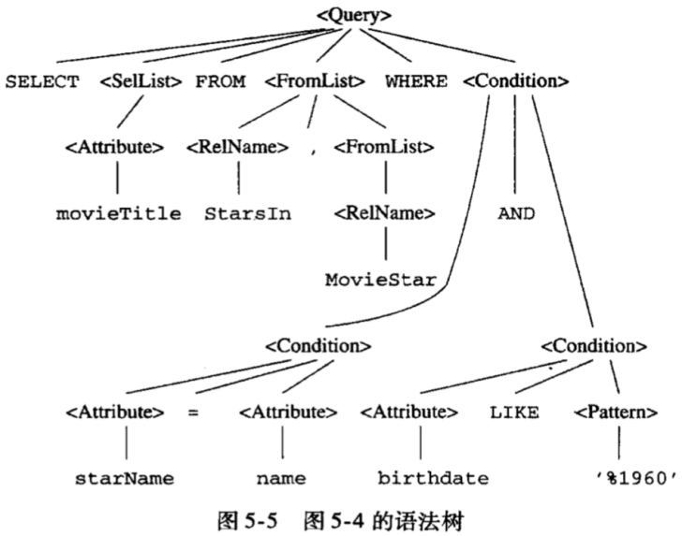

Here, we get the ***(1)*** Product of two Relations StarsIn and MovieStar in the ***from list***, and ***(2)*** proceed Selection by using the sub - tree in ***<Condition> root***, and ***(3)*** Project to the Selection list movieTitle. Finally, get the Relation Algebra Expression below:

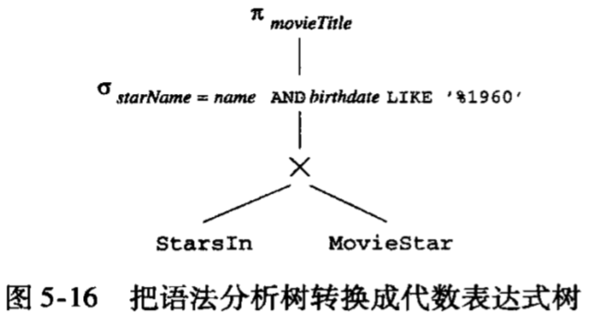

### Chapter 5.3.2 Remove Sub - Query from Condition

***(This Chapter is too detailed, maybe need to Re - read this later.)***

***Principle:***

For <Condition> that includes the Sub - Query Grammar Tree, we introduce the intermediate operator format, it is between Grammar Type of Grammar Analysis Tree and Relation Algebra Operator that operates on Relation. It is called *Two Parameter Selection*.

Here we use the node with the *tag α* and without any parameters to present the *Two Parameters Selection after conversion*. Also there exists one left node and it presents the Relation R which we need to operate on it, and also one right node, it presents the Condition Expression which has role on the Relation R.

*(Attention that two parameters can be presented as Grammar Tree, Expression Tree or combination of both.)*

***Example:***

Picture 5 - 17 is rewrite of Picture 5 - 3 by using Two Parameters Selection   
Operator for the Grammar Tree. There exist several conversions when constructing the new Grammar Tree.

1. The Sub - Query is substituted by one Relation Algebra Expression in 5 - 17.
2. Substituted by using *select - from - where* in outer query. Of course, here we use the *Two Parameter Selection* to present the necessary Selection, but not the common Relation Algebra Operator. Also, the upper Grammar Level Node <Condition> has not been substituted, but instead it still be as one parameter in Selection, and its round bracket and <Query> has been substituted by the Relation Algebra in the first point.

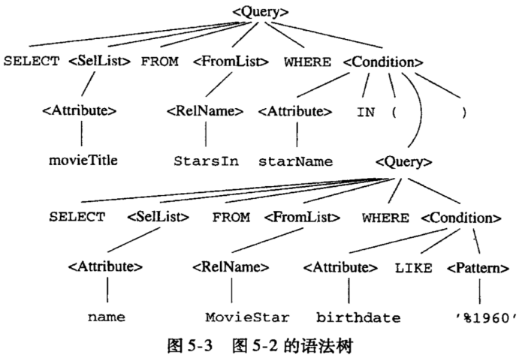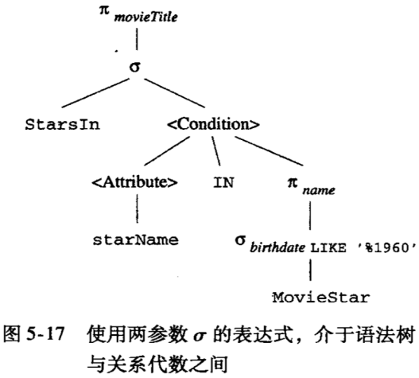

***Improvement:***

However, the tree above needs the further conversion, and the rule is needed to use the Single Parameter Operator and other Relation Operator to substitute the Two Parameters Selection Operator.

As an example, we will give the rule which relates with IN Operator. Attention here, the Query in the Sub - Query is not related, which is to say this Sub - Query can only be calculated once, since it has no relation with the checked tuples.

Here is the rule to eliminate such condition, and assume that we have a *Two Parameters Selection:*

1. One of the parameter represents the some Relation R.
2. The second parameter looks like *<condition> t IN S.*
3. Expression S is a Non - Relation Query.
4. t is a tuple consist by some attributes from Relation R.

***Conversion:***

1. Using the Expression Tree of S to substitute <Condition>. If S has repetition, then it is necessary to keep a Two Parameter Selection Operator in the root of S Expression, therefore the formed tuples will not exceed the number of tuples from original Query.
2. Using the Single Selection Operator to substitute the Two Parameter Selection, here we need to pay attention that condition C is each field in tuple t gets equal value with the corresponding field in Relation S.
3. Here give another parameter to Single Selection Operator, it is the product of R and S.

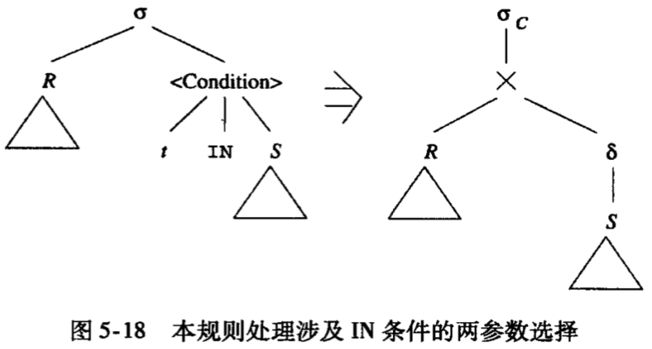

***Example:***

Consider that we have the tree below, then we will apply the rule ***<Condition> t IN S*** on the tree. Here, we need to pay attention that Relation R is ***StarsIn***, Relation S is the Algebra Result from Sub - Tree with the root of Projection name. Tuple t has a field, which is ***starName***. Here we need to convert Grammar tree from image 5 - 17 to the right format.

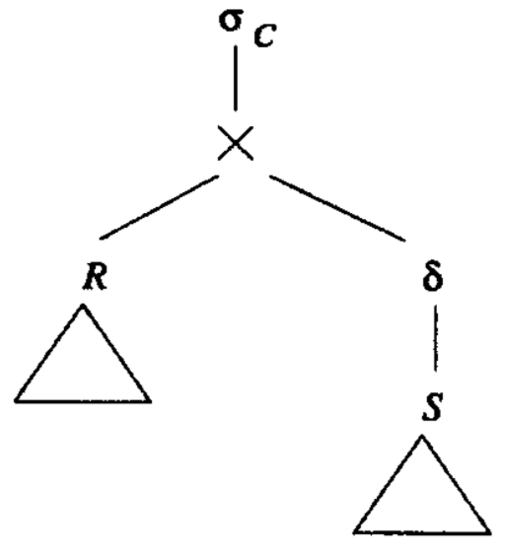

*Two Parameters Selection Operator* is substituted by *Selection (starName = name)*, the condition C is that one field of tuple t gets equal value with the result of Query S. Also one node of operator *α* is X node, and the parameter of X node is the node with Relation StarIn and the root of Expression of S in the right upper picture. Since the field name is the Key of Relation MovieStar, so there is no need to use Deduplication Operator.

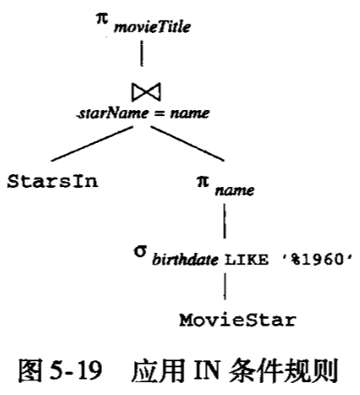

***Example:***

Below is Query “Find those whose average age is 40 at most when Movies were made.” with SQL represent. For more simpler, here we take birthdate as the year of birth, so then we can get one average value, which is used to compared with the attribute movieYear in Relation StarsIn.

*SELECT DISTINCT m1.movieTitle, m1.movieYear*

*FROM StarsIn m1*

*WHERE m1.movieYear - 40 <= (*

*SELECT AVG(birthdate)*

*FROM StarsIn m2, MovieStar s*

*WHERE m2.starName = s.name AND*

*m1.movieTitle = m2.movieTitle AND*

*M1.movieYear = m2.movieYear*

*);*

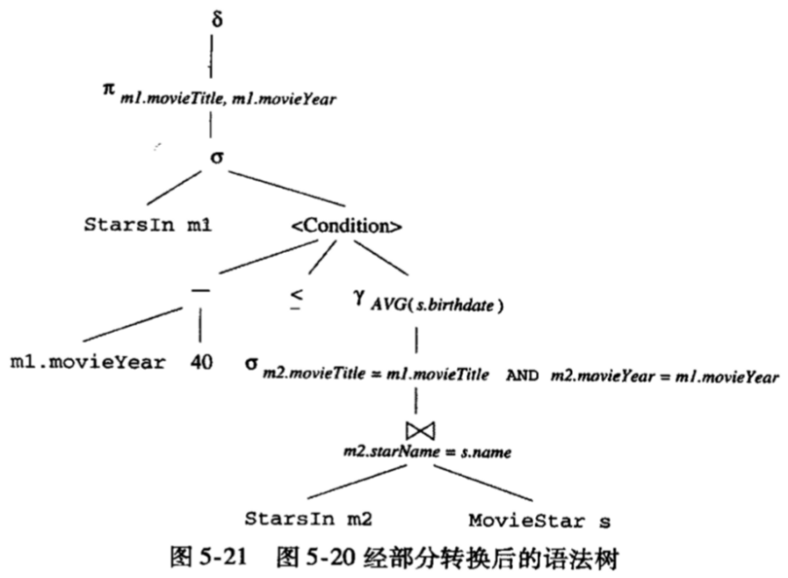

The image below depicts the *Logical Query Plan*.

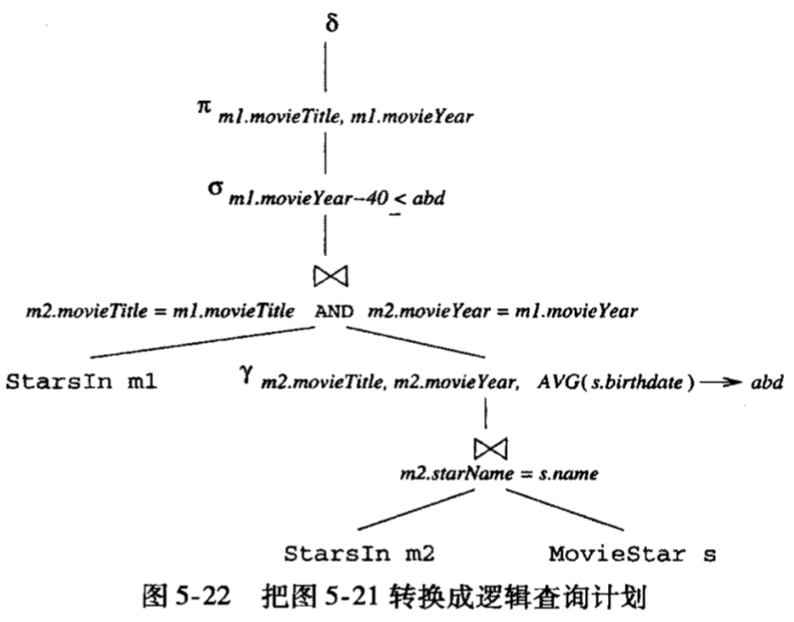

There have some more things that we can do in the *Query Optimizer*.

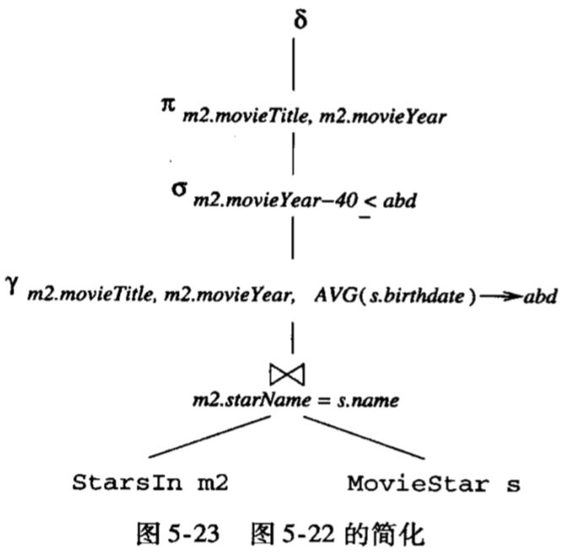

### Chapter 5.3.3 Improvement from Logic Query Plan

After we convert the Query Statement to Relation Algebra, then we can get one possible Logical Query Plan. Here is the Process:

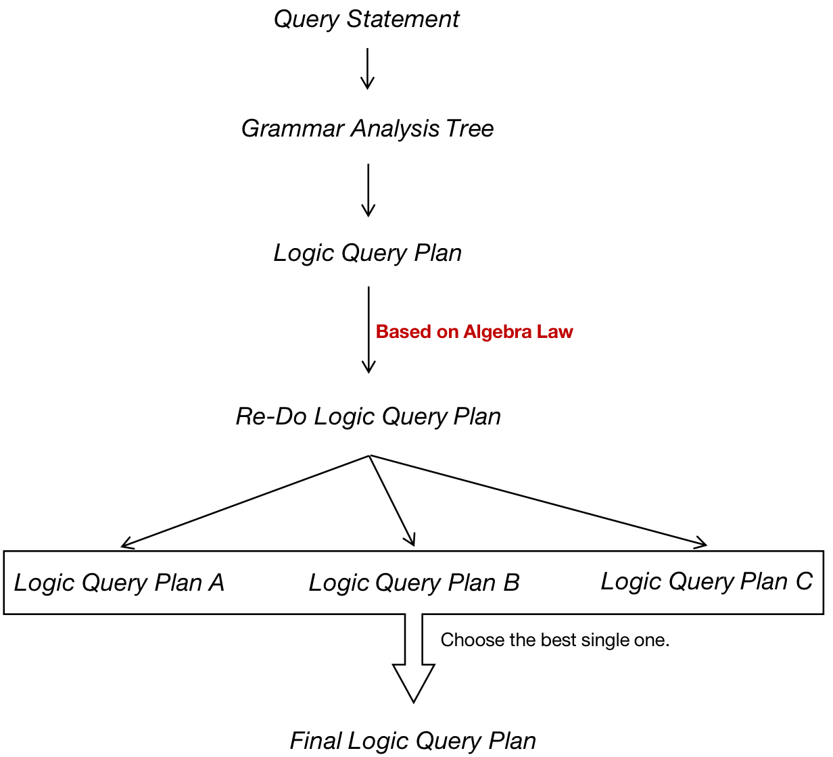

***Laws: (Used most in Optimizer)***

* Selection Operator can be pushed deeper to Expression Tree. If there exists one Selection Condition which is the multi - conditions with AND, then we can divide this condition and push each condition.
* Projection Operator can be pushed to the tree, or we can add new Projection.
* Deduplication Operator can be eliminated or moved to the more convenient place.
* Some Selections can be used to combine with Product and convert it to the Equal Value Join. Normally, calculate Equal Join is much more convenient than calculate two calculations.

***Example:***

Take the 5 - 16 as an example. We divide the Selection into two parts, one is *starName = name* while the other one is *birthdate LIKE ‘%1960’*. The latter one can be pushed on the Relation MovieStar, since the attribute birthdate comes from MovieStar. Also, the first condition relates to the two attributes of two Relations, so here we get the Equal Value. So Product and Selection can be combined as Join with Equal Value.

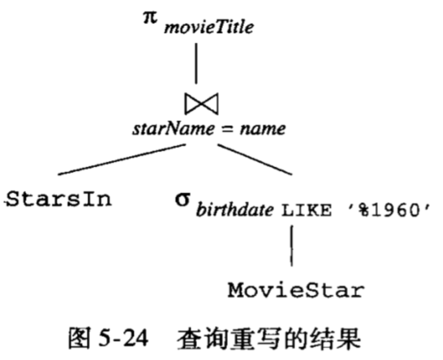

### Chapter 5.3.4 Grouping of Combinative and Distributable Operator

***Principle:***

*Those Operators that satisfy Combinative and Distributable Law can be seen as Operators that can have several Operators.*

So the last step before we generate the final Logic Query Plan is: For each part of those sub - tree which consists of the Combinative and Distributable Operator nodes, we can make these nodes as one single node with multi children.

*(Attention that the normal rule that satisfies Combinative and Distributable Operators are Natural Join, Union and Intersection.)*

Under special situation, Natural Join and Theta Join can be combined with each other:

1. We must use Theta Join to substitute the Natural Join and get the Equal Value for those properties with the same property names.
2. We must add one Projection Operator into Theta Join to eliminate all repetition properties which are involved in the Natural Join.
3. The condition of Join must be Combinative.

Product Operator is the special case in Natural Join, and if it is the neighbor of Join in the tree, then it can be combined with Theta Join. The picture below shows such conversion. Attention that alphabet R to W represents random Expression, but not the Storage Relation.

